GAME DESIGN DOCUMENT:

Platform 2D game

Group 8

Index:

STORYLINE: 3

MAIN CHARACTER 3

GAME DESIGN: 3

CONTROLS: 5

PLATFORMS: 5

SCORE AND ASSESSMENT: 5

TARGET USERS: 5

GRAPHICS AND SOUNDS: 6

# STORYLINE:

The story is about a soldier that fought along his friend during the invasion of our country, we start it when fighting along him for learning how to use our soldier: jumping, aiming, shooting… would be taught during that mission.

After we win and make our enemies leave the country we found a devastated land, with so many inner conflicts that it can't stay like that, so we get a civil war. In this civil war we join one side because it's what we think it's the best for us but our once friend not only joins the other but also he becomes an important leader of it.

So now our main goal is to fight over our levels to get him and defeat him to win peace over our once peaceful world.

# MAIN CHARACTER

The main character will be selected from the play button if we’re playing for the first time where we’ll be able to pick its gender and what it looks like; two or three choices will be displayed so the player can choose the one that likes the most.

The kind of looks it should have will be something that looks like a 8 bit soldier, so the differences can’t change much apart from the looks of the armor and if the character has quite longer hair than the other choices (to make it a girl), so it won’t be too different if we compare with what we’re used to today.

Apart from that, we’re thinking about animating the main character so we will be able to see when it walks, when it jumps and when it shoots.

When in the game, it will start with three lives and a number of ammo that will be reducing whenever it gets hit by one enemy or shoots itself. The ammo can be recharged when hitting the targets, because they’ll leave the one that they haven’t used from what they’re given when they’re created.

# GAME DESIGN:

At the beginning the design is about three different levels, one for the tutorial, when via text messages that come out of NPCs we learn the basic control of our player, how to shoot, how to jump, basic movement... and we get to complete an easy level with a few enemies and with a helping NPC that's our friend that afterwards becomes our enemy.

Then we get to the second level where we start to fight our once friend's army, the difficulty has increased and now we have to gather coins to buy improvements on our skills or weapons. Since the game is not set in any certain time (although we can guess it would be in the XIX century approximately) we have a variety of weapons such as guns but also swords and spears.

In the third level we get a much harder platform game with more NPCs and no help and, at the end of it we will have to fight our once friend in the story who will be the final boss.

For the user interface, at first a main menu will be displayed where the player that's about to start will be able to click a play button that will start from the very beginning or click a select level one, where the player will be able to pick the required level that will be unblocked once it has been played before, so players won't be able to just start from some mission before unlocking the previous ones.

When the player loses all its lives the main menu will be displayed because we’d have lost the game.

In the game menu the options displayed will work like:

Play −------→ It starts on level 1

Select level −------→Move to panel with choices

Quit −------→ Click to leave game

The choices on the main menu panel will be displayed like this:

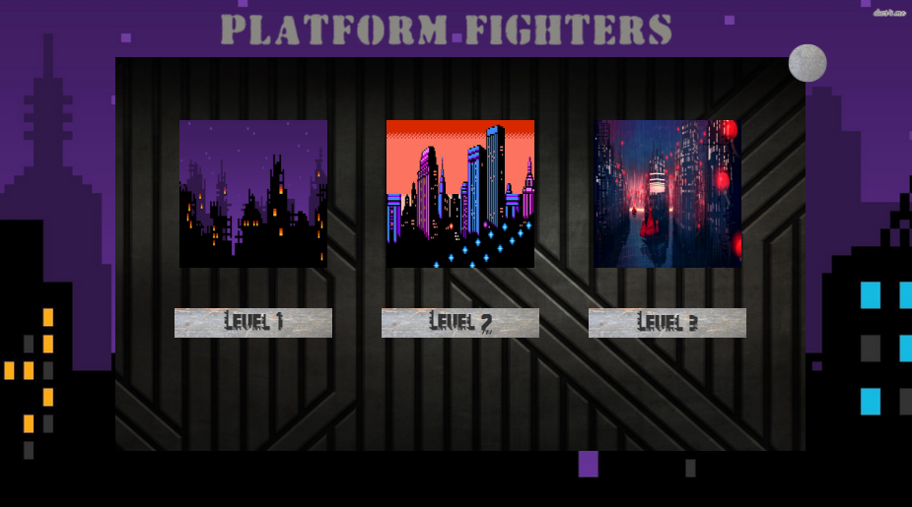

And we’ll be able to pick the level we want once we have unlocked them.

# CONTROLS:

The game will be controlled by the player with the keyboard, the keys used for playing will be:

* + Left arrow for moving left
  + Up arrow for jumping
  + Right arrow for moving right
  + moving mouse for aiming
  + left button of mouse for shooting

# PLATFORMS:

The game should be played in computers and browsers, since it's a very easy game to control and that doesn't require much but, since it's this easy it could be easily playable in devices such as phones or tablets as well but we're still not looking forward to that.

# SCORE AND ASSESSMENT:

In our game we're implementing a coin system, where when you kill enemies you will get some reward in coins, those coins will be used later to upgrade your character in a store that will be displayed at the end of each level.

We're also thinking in a system of punctuation where at some points the character will level up, even though that can also be done with the previously described coin system.

# TARGET USERS:

Our game is not a hard one so everyone could play it, but since it's a game with some violent content (even though it isn't any hard with blood or moral issues) it should be a game played by people from 7 years old. Basically the only items that could make this game disapprove by people from some ages might be the fact that there's shooting action and you have the power of killing NPC. Even though, no blood or any kind of active violent acts are shown, understanding that as the only kind of violence displayed would be the shots hitting the target and making this target disappear leaving a bonus, such as it would happen in “Super Mario Bros”.

Therefore, the age would be for people over 7 years old, even though kids before that age could do so if they play games like “New Super Mario Bros” or similar.

# GRAPHICS AND SOUNDS:

Our game will have basic graphics such as a picture displayed on the background, simple NPCs and a simple main character, the shots that the playable character displays will have some texture as well and the platforms will too.

Sounds will be displayed such as a shooting sound whenever we shoot, another sound when we fall to the bottom platform or when we die.

We will have four different kind of music, one for the main menu, and other three ones for each level that we’ll play.

Here’s a view of what the main menu looks like: 